**a PROJECT REPORT ON**

**VOICE CONTROL CHESS**

SUBMITTED TO SAVITRIBAI PHULE PUNE UNIVERSITY FOR PARTIAL FULFILLMENT

OF THE REQUIREMENTS for the award of the DEGREE OF

**BACHELOR OF ENGINEERING**

in

Electronics and Telecommunication Engineering

By

**SHUBHAM KANSE 71700931K**

**OMKAR KAMBLE 71700926C**

**SAKSHI LOHIYA 71701177B**

**GUIDE**

**DR. PRADEEP VARADE**

**Department Of**

**Electronics and TELECommunication ENGINEERING**

**PUNE INSTITUTE OF COMPUTER TECHNOLOGY PUNE – 43**

**Academic Year: 2019-20**

Department of Electronics and Telecommunication Engineering

Pune Institute of Computer Technology, Pune – 43

**CERTIFICATE**

This is to certify that the project report entitled

**VOICE CONTROL CHESS**

has been successfully completed by

Shubham Kanse 71700931K

Omkar Kamble 71700926C

Sakshi Lohiya 71701177B

Is a bona fide work carried out by them towards the partial fulfillment of the requirement of the Savitribai Phule Pune University, Pune for the award of the degree of the Bachelor of Engineering in Electronics and Telecommunication Engineering. This project work has not been earlier submitted to any other Institute or University for the award of any degree or diploma.

Dr. P.S. Varade Dr. S.V. Gaikwad Dr. P.T. Kulkarni

Project Guide HOD, E&TC Dept Principal, PICT

Place: Pune

Date : 6/04/2020

**ACKNOWLEDGEMENTS**

We are very thankful to our guide Dr. Pradeep Varade for guiding us in each step of this project since the project has been announced. We would also like to thank our assessment guides Ms. Manjeeta Kale and Prof.A.A Bhandekar for analyzing our work and advising us to take the right step. We would like to express our gratitude to Prof. R.C. Jaiswal to helping us to carry out various activities under his venture.

We would like to extend our gratitude to all the staff members of the E&TC department for always supporting and encouraging us in each situation. Last, but not the least, we would like to mention specially Dr S.V. Gaikwad, Head of E&TC department, and Dr. P. T. Kulkarni, Principal of PICT, giving this wonderful opportunity to extend our knowledge.

Thanking You!

Shubham Kanse

Omkar Kamble

Sakshi Lohiya

**CONTENTS**

|  |  |  |  |
| --- | --- | --- | --- |
|  | **Abstract** | | i |
|  | List of Acronyms & Symbols | | ii |
|  | List of Figures | | iii |
|  | List of Tables | | iv |
|  |  | |  |
| **1** | **Introduction** | |  |
|  | 1.1 | Background / Context | 1 |
|  | 1.2 | Relevance | 2 |
|  | 1.3 | Literature Survey | 2 |
|  | 1.4 | Motivation | 3 |
|  | 1.5 | Aim of the Project | 3 |
|  | 1.6 | Scope and Objectives | 3 |
|  | 1.7 | Technical Approach/ Methodology | 4 |
|  |  |  |  |
| **2** | **Theoretical Description of Project** | |  |
|  | 2.1 | Theoretical background | 5 |
|  | 2.2 | Technical specification of the project, resources required |  |
|  | 2.3 | Block diagram | 7 |
|  | 2.4 | Flow chart /Algorithm | 8 |
| **3** | **System Design** | |  |
|  | 3.1 | Block wise design | 11 |
|  | 3.2 | Components/devices selection | 16 |
| **4** | **Implementation, Testing and Debugging** | | 18 |
| **5** | **Results and Discussion** | | 21 |
| **6** | **Conclusions** | | 23 |
| **7** | **Future Scope** | | 24 |
| **8** | **References** | | 25 |
| **9** | **Appendix** | |  |
|  |  | |  |

**ABSTRACT**

Chess is a game loved by people of all ages, but for individuals who cannot use their hands—whether due to a disability or other limitations—playing on a traditional chessboard can be challenging. The **Voice-Activated Chess Set** is designed to make the game more accessible by allowing players to move pieces using only voice commands.

This system uses **speech recognition technology** to interpret pre-set commands, enabling players to control the board without physical interaction. The chess pieces are made of plastic with small iron components underneath, which are manipulated by an **electromagnetic system.** A motorized **X-Y axis mechanism** moves the pieces to their designated positions, ensuring they follow standard chess rules.

Unlike digital chess applications, this system preserves the **tactile experience of a physical chessboard**, making the game feel more authentic and engaging. With improvements in **microphone accuracy and voice recognition software**, the system can become even more responsive, reducing misinterpretations and enhancing gameplay.

This project aims to provide a **hands-free, independent chess experience** for those who might otherwise struggle to play. Future enhancements could include AI-powered move suggestions, multiplayer capabilities, and integration with smart home technology to further improve accessibility and ease of use.

**List of Acronyms & Symbols**

|  |  |  |  |
| --- | --- | --- | --- |
|  | **Name** | **Details** | **Section** |
| 1. | Rpi | Raspberry Pi | 2.1 |
| 2. | NEMA | NEMA 17 stepper motor | 3.2 |

**List of Figures**

|  |  |  |
| --- | --- | --- |
| Fig 1. | Objective tree | 4 |
| Fig 2. | Basic hardware interfacing. | 7 |
| Fig 3. | Basic steps for a command. | 8 |
| Fig 4. | Steps for piece elimination. | 9 |
| Fig 5. | Steps for castling command | 10 |
| Fig 6. | Sliding system. | 11 |
| Fig 7. | Hardware interfacing. | 13 |
| Fig 8. | Upper view of the system. | 14 |
| Fig 9. | Chess piece structure. | 15 |
| Fig 10. | Command transmission steps. | 18 |
| Fig 11. | Working of system. | 19 |

**List of Tables**

|  |  |  |
| --- | --- | --- |
| Table 1 | Components and specifications. | 17 |
| Table 2 | Observations. | 20 |
| Table 3 | Progression of the project. | 22 |

**CHAPTER 1**

**Introduction**

* 1. **Background/context**

There are many different chess board designs which are like our project. But There is one design in particular that is similar to the group’s design which is the voice activated chess-set. The voice activated chess-set has the same objective as the group which is a chess set with self-moving, and voice activated chess pieces. The voice activated chess-set design has only one mode of operation which is a player against the computer. player against a second player is not available

The group decided to have both mode of operation which is to have the chess set be a two-player game as well as player against AI. The voice activated chess-set used a chess engine and the group decided against using a chess engine; instead to use micro-controllers and chips. Also, there is another similar project the Magic Chess Set board which used a microATX motherboard to control the voice commands and chess engine, which would go over the group’s budget and which is a huge chess set and very slow to play.

The Magic Chess Set did not incorporate chess movements like castling, pawn promotion, and en passant. The group would like to keep the chess game as close to the traditional rules, so castling, pawn promotion, and en passant will be used. The group wants to use voice commands that are more fluent like “A-3 to A-4” oppose to the Magic Chess board command of “A3A4” The Magic Chess Set uses a combination of two stepper motors to make an X-Y table to relocate the chess pieces. Just like the Magic Chess Set, the group decided to use a combination of two stepper motors to make an X-Y table. This design of the X-Y table is the most efficient way to move chess pieces from underneath of the chess. But all of these projects/products are made in foreign countries like UK and USA. These projects are not available in India and those we can order are way too costly to purchase it for common people. Thus, the group decided to make a voice activated chess set taking guidance from all of these pre-existed chess models and make our own which will be the less costly compared to the other chess models and will be small in size and less heavy.

.

* 1. **Relevance**

Nowadays, the young generation is not interested in playing outdoor or indoor games instead they are interested in playing a lot of video games, mobile games, various other computer sensations and similar sort of entertainment which are most likely to harm them in some way or the other. Voice controlled chess set would not only fascinate them but also urge the fun for them without any means of harm.

* 1. **Literature Survey**

Chess history goes back nearly 15 centuries The game began in northern India in the 6th century AD and spread to Persia When the Arabs invaded Persia, chess was taken over by the Muslim world and then spread to southern Europe through the Moorish invasion of Spain. But in early Russia, the game came directly from the Khanates (Muslim territories) to the south.

Since then, the chess has evolved considerably in the 17th century, the mechanically automated chess known as "the Turk" has been created. And as the days went by, technology then science made it possible to make it work electronically so many more chess available now - a-days than operating automatically with robotic arm, using holograms and moving pieces still made it possible automatically.

There are many different chess board designs which are like our project. There is one design that is voice activated chess-set. The voice activated chess-set is a chess set with self-moving, and voice activated chess pieces. The voice activated chess-set design has only one mode of operation which is a player against the computer. player against a second player is not available. This project is built in Nottingham University. There are another similar projects in some way or other but all of them are available out of our country.

* 1. **Motivation**

The concept of hands free chess comes from the J.K. Rowling book and Warner Brothers’ movie, Harry Potter and the Sorcerer’s Stone. In the movie, Harry and Ron tell the pieces where they want them to move and the pieces move themselves to that location without any physical interaction from a human.

According to survey of Government of India in India there are about 2.1 million people, that makes a whole up to 2.1% of the country’s population who are not capable of performing basic physical activities . Within this number are people who cannot use their arms, but the estimate, unfortunately, does not include soldiers who lost their limbs, people with terrible arthritis in their hands, or individuals with hand tremors. There are a large amount of people just in that have to depend on others to perform day to day tasks. The Voice-Controlled Chess Set will let the person be able to depend on themselves to play a fun and challenging game of chess.

Also nowadays, the young generation is not interested in playing outdoor or indoor games instead they are interested in playing a lot of video games, mobile games, various other computer sensations and similar sort of entertainment which are most likely to harm them in some way or the other. Voice controlled chess set would not only fascinate them but also urge the fun for them without any means of harm.

* 1. **Aim of the Project**

The aim of the chess board design is to be able to play a fast responding and long-lasting game of chess solely using voice-controlled commands. This will allow the players to enjoy a game of chess without depending on their arms.

* 1. **Scope and Objectives**

**Scope:**

The Voice-Activated Chess Set is designed to provide an accessible and interactive chess-playing experience, enabling users to play without physical interaction. The scope of this project includes:

* **Online Multiplayer Capability**: The game can be played against anyone worldwide via an internet connection, allowing for remote gameplay.
* **AI Difficulty Levels**: Players can choose from different levels of difficulty when competing against an AI opponent, making the game suitable for beginners and advanced players alike.
* **Voice Differentiation for Fair Play**: The system will be capable of detecting and distinguishing between two different voices, ensuring fair play when two human players compete.

**Objectives:**

The primary objective of this chessboard design is to develop a fast-responding, durable, and fully voice-controlled chess game that allows players to move pieces effortlessly using voice commands. The objectives are divided into two main categories:

**Technical Objectives:**

* Implement an accurate and responsive voice recognition system for seamless control.
* Develop a real-time piece movement system using an X-Y axis motor mechanism.
* Use an electromagnetic system to manipulate chess pieces precisely.
* Ensure low-latency responses to make gameplay feel smooth and natural.
* Optimize the system for long-term durability and minimal maintenance.

**Design and Physical Objectives:**

* Maintain a traditional chessboard appearance while integrating voice-controlled movement.
* Use high-quality, durable materials for the board and pieces.
* Keep the design compact, ergonomic, and user-friendly, making it easy to set up and operate.
* Ensure that the system is aesthetically appealing while maintaining full functionality.

By addressing both the technical and physical aspects, this project aims to create a seamless, hands-free chess experience that enhances accessibility, engagement, and enjoyment for all players.

Fig 1. Objective tree.

**CHAPTER 2**

**Theoretical Description of Project**

**2.1 Theoretical background**

The system will include an Android app called **"Arduino Voice Control."** This app enables the system to recognize spoken commands, convert them into text, and send them via Bluetooth to the Raspberry Pi (Rpi). It utilizes **Google Voice Recognition**, which requires a Wi-Fi or mobile data connection.

When a voice command is received, the smartphone converts the speech into an **audio file** and sends it to Google's servers for processing. Using a **cluster of interconnected computers**, Google’s system analyzes the audio frequencies and compares them against pre-recorded voice samples. If the margin of error falls within an acceptable threshold, the system identifies the spoken phrase and returns a **text file** containing the recognized command.

Although this technology is effective, it is not perfectly precise, and errors may occur if the recognized text differs from the expected command. To address this, an **LED indicator** will be added to the system. It will blink when a command is correctly recognized and processed.

Once the correct string is generated, it is transmitted to the Rpi via **Bluetooth serial communication** operating on the **2.4 GHz band**. For instance, if the recognized command is **"A2 B6,"** the system understands that "A2" represents the starting position and "B6" represents the destination.

**Piece Movement and Board State Tracking**

To execute the move, the system must first verify whether the destination square is occupied. At the start of the game, an **array** is initialized with values representing all occupied squares on the board. The system uses a **numerical representation** for each square:

* **Numbers remain unchanged** (1 = 1, 2 = 2, etc.).
* **Letters are converted into multiples of 10** (A = 10, B = 20, C = 30, etc.).

For example, if the square **C3** is occupied, the list stores it as **33** (C = 30, 3 = 3). If the command specifies moving a piece to **B6**, the system checks whether **26** (B = 20, 6 = 6) exists in the list of occupied squares:

* **If 26 is present**, the system removes the existing piece by using the motors to drop it into a collection box.
* **If 26 is not present**, the system proceeds with the move.

After executing the move, the system updates the list:

* **The starting position (A2) is removed** from the occupied squares list.
* **The destination position (B6) is added** to reflect the new board state.

**Executing the Movement**

Once the board state is confirmed, the system converts the move from letter notation to **numerical coordinates** (A = 1, B = 2, etc.). It then calculates the required movement:

* The piece moves **horizontally** to the right and **vertically** upwards.
* The **X-Y axis stepper motors** execute this movement, ensuring smooth operation.
* A **delay() function** is used to allow each move to complete before proceeding.

Next, the **electromagnet is activated** to pick up the chess piece. The electromagnet functions by generating a **strong magnetic field** when current flows through it. Since all chess pieces have **iron bases**, they are magnetically responsive and can be picked up effortlessly.

A **relay switch** is integrated into the system to control the electromagnet. Once activated, the system carefully moves the piece along the board lines to avoid knocking over other pieces. At the destination square, the electromagnet releases the piece, and the motors make minor **corrections** to center it within the square.

**Resetting for the Next Move**

After completing a move:

1. The **motors return the magnet** to square **A1**, positioning it for the next command.
2. The **LED turns off**, signaling that the system is ready to receive a new move.
   1. **Block diagram of overall system**

The voice input is taken through microphone and is converted into sequential data. The Raspberry pi is used to process the sequential data and to determine if the player is following correct chess rules, if yes, it will generate the signal and send it to position system which will actuate the movement of pieces and using stepper motor and solenoid the chess piece will be moved to its desired position.

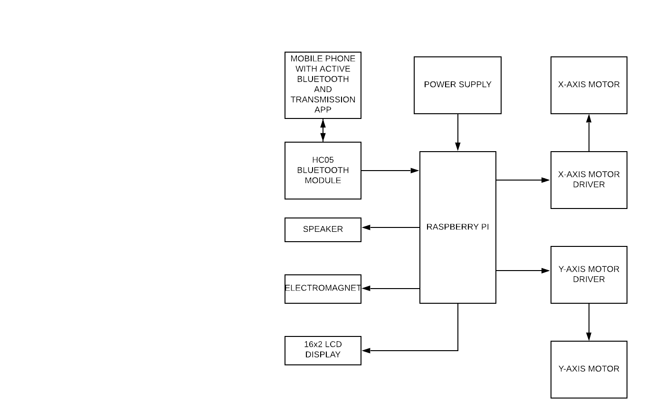

Fig 2. Basic hardware interfacing.

**2.3 Flow chart /Algorithm**

2.3.1 Basic Mechanism for Voice Control Chess Board:

The voice input command is taken from the user and if the command the user has send is valid then it will move the chess piece from it’s current address to desired address and if the input command from the user is invalid then it will not move the chess piece from its current position and will take the voice command from the user again.

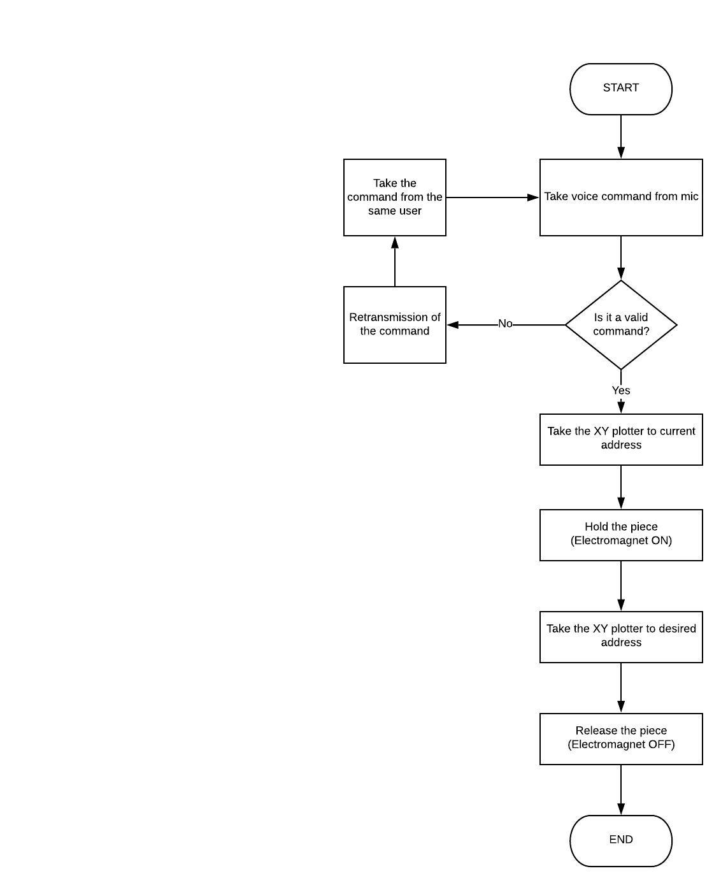

Fig 3. Basic steps for a command.

**2.3.2 Mechanism For eliminating the piece:**

After receiving the correct voice command it will check if the opponent piece is present on the desired address, if yes then it will go to the desired address hold the opponent piece and will take it to lobby C and drop that piece and then it will go to it’s current address hold the piece and will take it to its desired address.

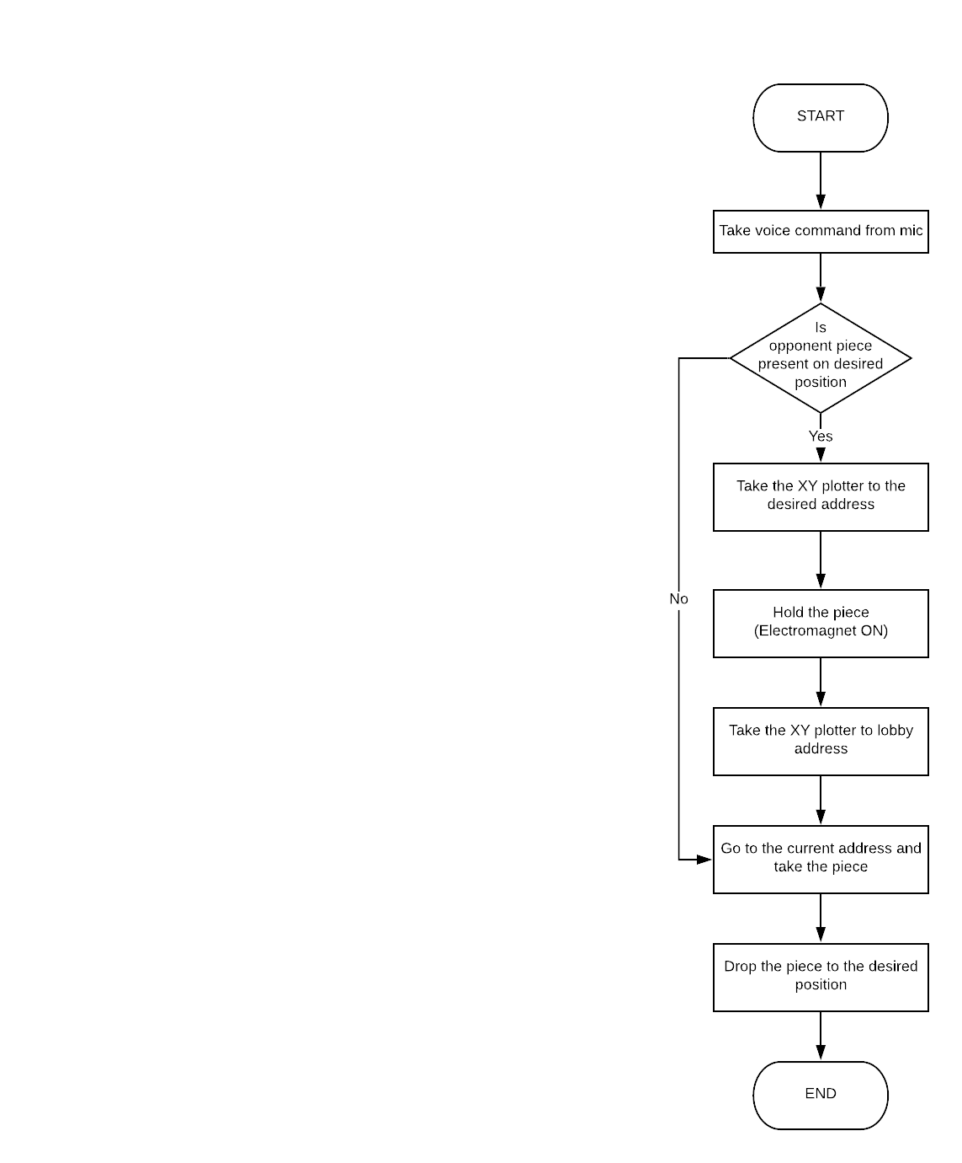

Fig 4. Steps for piece elimination

**2.3.3 Mechanism For special move- Castle:**

Castling is a very important move in a chess game and the system has provided this move in the game and this is how it is achieved.

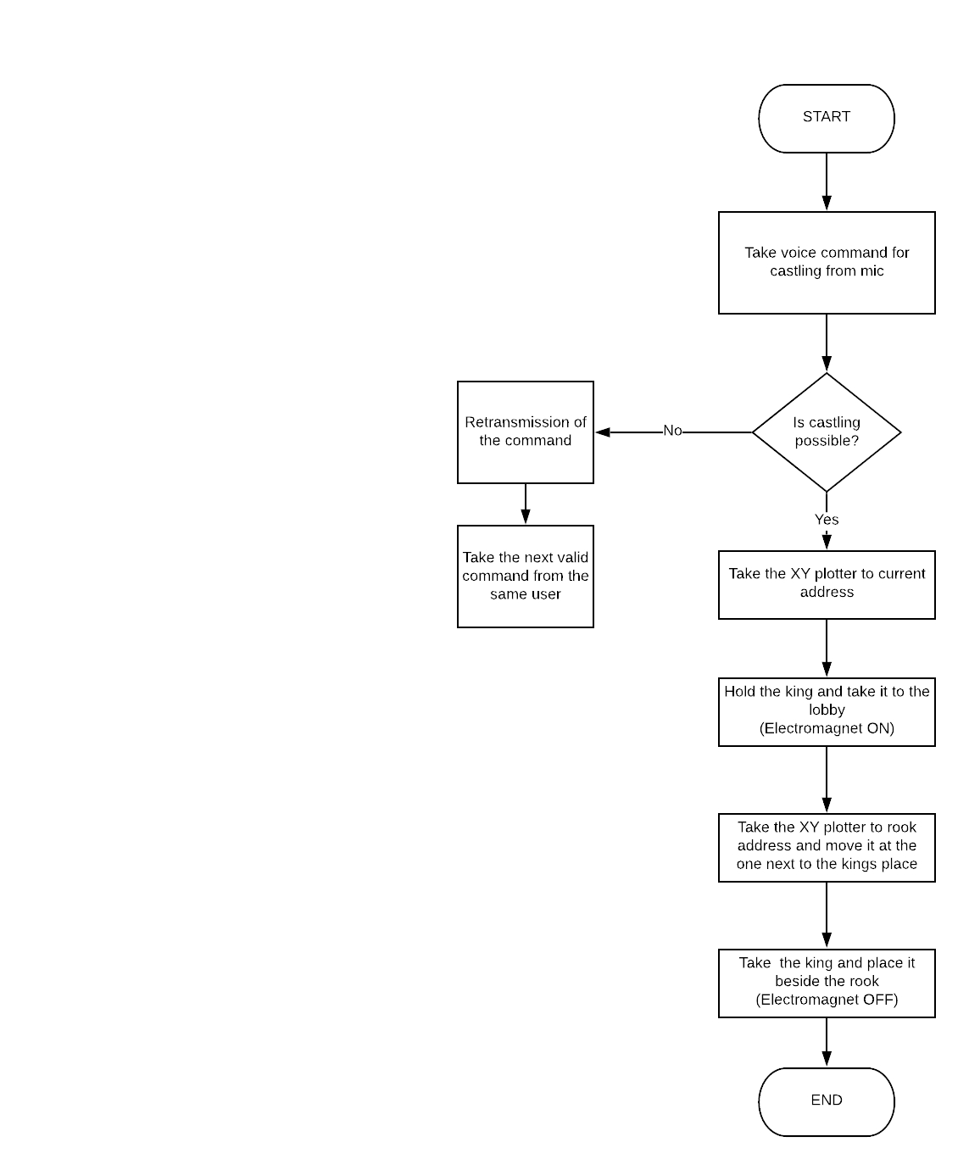

Fig 5. Steps for castling command

Fig 5. Steps for castling command

**CHAPTER 3**

**System Design**

**3.1 Block wise design**

System block is divided into three sub-blocks viz. Positioning system, internal hardware part and lastly the user interface of the project.

* + 1. **Positioning system**

The positioning system consist of three parts which are X-axis or horizontal motion , Y-axis motion or vertical motion and electromagnet.

Fig 6. Sliding system.

The design called for an electromagnet to couple with the chess pieces. The electromagnet was designed by using fundamental electromagnetic equations to determine the current and number of turns needed to generate the appropriate force on the chess pieces. The electromagnet was desirable because of the easy idea of turning it on/off. To turn it on/off all that needed to be done was turn on/off current to the windings. The design that the electromagnet would have the right amount of magnetic force to attach to the pieces.

This electromagnet is attached over the Y-axis moving board on which it can move in horizontal motion with the help of the motor which is also mounted on the moving board. The board has its vertical motion due to another motor which is attached on the base of the board. Thus electromagnet can have vertical motion , horizontal motion and also diagonal motion if both of the motors run simultaneously.

* + 1. **Internal hardware system**

It consists of all the electrical circuitry, The motors, board, microprocessor, batteries, bluetooth module etc. Will be under the roof of the layout.

Fig 7. Hardware interfacing.

* + 1. **Chess board**

**3.1.3.1 Overall chess board**

The dimensions of the chess board are 60cm x 60cm x 25cm thus making the system smaller than other compared systems. The boards layout is made up of acrylic material so the electromagnet will not be interrupted while moving the pieces. Base of the board is made up of wood. And railings are made up of plastic on which the electromagnet is moving. To remove the eliminated pieces the system is built up with a box on either side of the board the eliminated piece can be slides into the box. Inside of the chess board the location of the power supply, microprocessor, voice activation module, speaker, and circuits can be found.

**3.1.3.2 layout of the chess board**

The area where the chess game is played is called the playing board. The playing board that system has have an 8 by 8 grid with 5 cm x 5 cm squares (total area of 40 cm x 40 cm). Plus the system has two extra grid on each side to side cast the temporarily move the piece from that side which is also of 5cm x 5cm. (Thus making the whole game board of 40cm x 50cm).

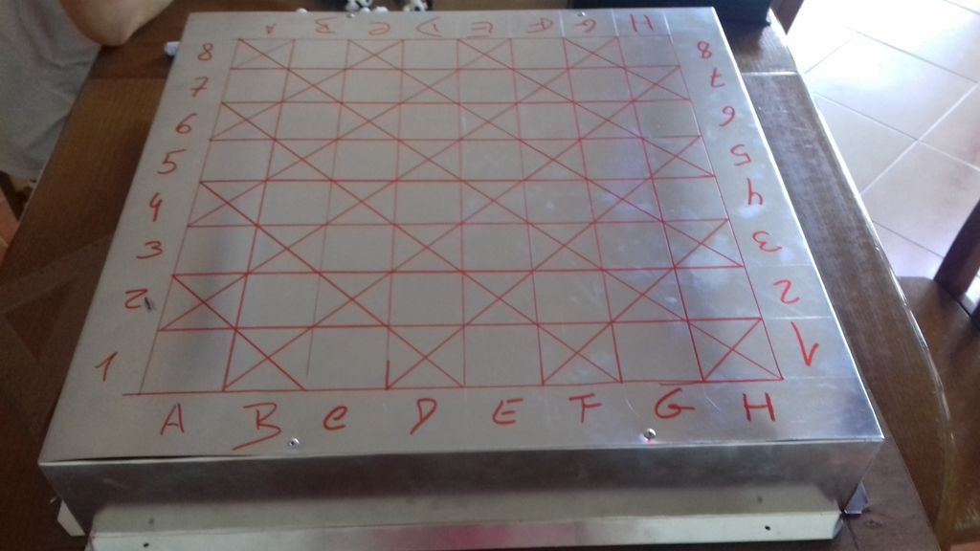

Fig 8. Upper view of the system.

**3.1.3.3 chess pieces**

The chess pieces should be lightweight and should have the base that can be attracted by the electromagnet. The chess pieces are of small size compared to the square box. So when the electromagnet attracts the pieces it will not attract the neighbouring pieces .the chess pieces the system has are made up of plastic which are lightweight and at the base metal washers are attached thus electromagnet can attract the washer and piece can be move smoothly. The first initial set up of the board, the pieces will need to be physically placed on the board. After the first initial set up the pieces will not need physical assistance again as the position system will reposition the pieces. A game that would be played is hands free because the position system can move the pieces from the sides of the board, the graveyard slots, to the starting positions.



Plastic chess piece

Iron washer at the base to attract electromagnet

Fig 9. Chess piece structure.

**3.2 Components/devices selection**

Table 3.1: Showing component and its specification

|  |  |  |  |  |
| --- | --- | --- | --- | --- |
| Sr. No | Component | quantity | specification | cost |
| 1 | 3 17 stepper motor | 2 | Size: 42.3 mm square × 48 mm, not including the shaft (NEMA 17)  Weight: 350 g (13 oz)  Shaft diameter: 5 mm “D”  Steps per revolution: 200.  Current rating: 1.2 A per coil.  Voltage rating: 4 V.  Resistance: 3.3 Ω per coil.  Holding torque: 3.2 kg-cm (44 oz-in) | 550/- each |
| 2 | Raspberry pi (Rpi) | 1 | SOC: Broadcom BCM2837B0, Cortex-A53 (ARMv8) 64-bit SoC  CPU: 1.4GHz 64-bit quad-core ARM Cortex-A53 CPU  RAM: 1GB LPDDR2 SDRAM  WIFI: Dual-band 802.11ac wireless LAN (2.4GHz and 5GHz ) and Bluetooth 4.2  Ethernet: Gigabit Ethernet over USB 2.0 (max 300 Mbps). Power-over-Ethernet support (with separate PoE HAT). Improved PXE network and USB mass-storage booting.  Thermal management: Yes  Video: Yes – VideoCore IV 3D. Full-size HDMI  Audio: Yes  USB 2.0: 4 ports  GPIO: 40-pin  Power: 5V/2.5A DC power input  Operating system support: Linux and Unix | 3175/- |
| 3 | A4988 Stepper Motor Driver | 2 | * Max. Operating Voltage: 35V * Min. Operating Voltage: 8V * Max. Current Per Phase: 2A * Microstep resolution: Full step, ½ step, ¼ step, 1/8 and 1/16 step * Reverse voltage protection: No * Dimensions: 15.5 × 20.5 mm (0.6″ × 0.8″) * Short-to-ground and shorted-load protection * Low RDS(ON) outputs * Thermal shutdown circuitry | 150/- each |
|  | HC05 Bluetooth module |  | * Bluetooth protocal: Bluetooth Specification v2. ... * Frequency: 2.4GHz ISM band. * Modulation: GFSK(Gaussian Frequency Shift Keying) * Emission power: ≤4dBm, Class 2. * Sensitivity: ≤-84dBm at 0.1% BER. * Speed: Asynchronous: 2.1Mbps(Max) / 160 kbps, Synchronous: 1Mbps/1Mbps. * Security: Authentication and encryption. | 350/- |
|  | 16*2 lcd display |  | Supply voltage; 5V (4.7V – 5.3V) | 185/- |

Table 1. components and specifications.

**CHAPTER 4**

**Implementation, Testing and Debugging**

**4.1 Working of the internal hardware**

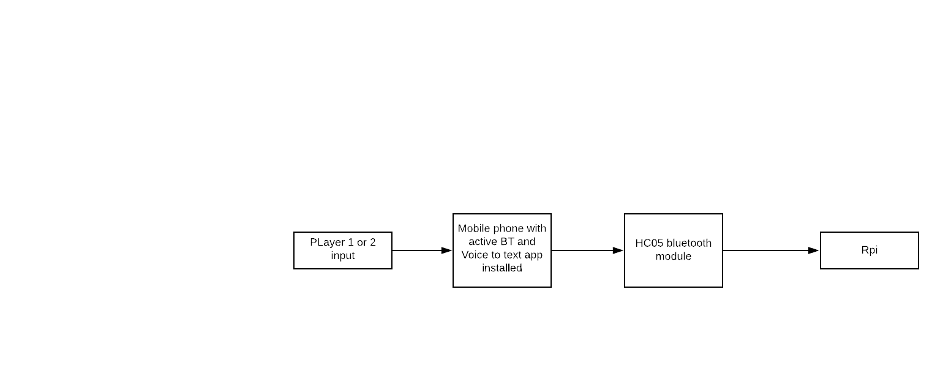The players are going to send the voice input via a mobile device which has a bluetooth connection and a app which can convert voice format to text format. This text data is then received by the HC05 bluetooth module and then further sending it to the Rpi microprocessor.

Fig 10. Command transmission steps.

The Rpi will have pre-loaded data i.e. commands for the pieces the microprocessor will analyze and compare the data with the given input if the input is wrong or invalid it will ask the player to re-transmit the command. This can be done via showing the message on the 16x2 LCD display. If the command is valid then Rpi will give the instructions to the positioning system. And then positioning system will take our piece to the desired location.

**4.2 Working of the positioning system**

The positioning system consist of three parts which are X-axis slider, Y-axis slider and electromagnet.

This electromagnet is attached over the Y-axis moving board. The electromagnet can move in horizontal motion with the help of the motor which is mounted on the moving board. The board has its vertical motion due to another motor which is attached on the base of the main board. If player sends a valid command then the XY slider will move towards the piece that has to move and it’ll will hold it using electromagnet and it will take the piece to the desired location and then it’ll turn off the electromagnet.

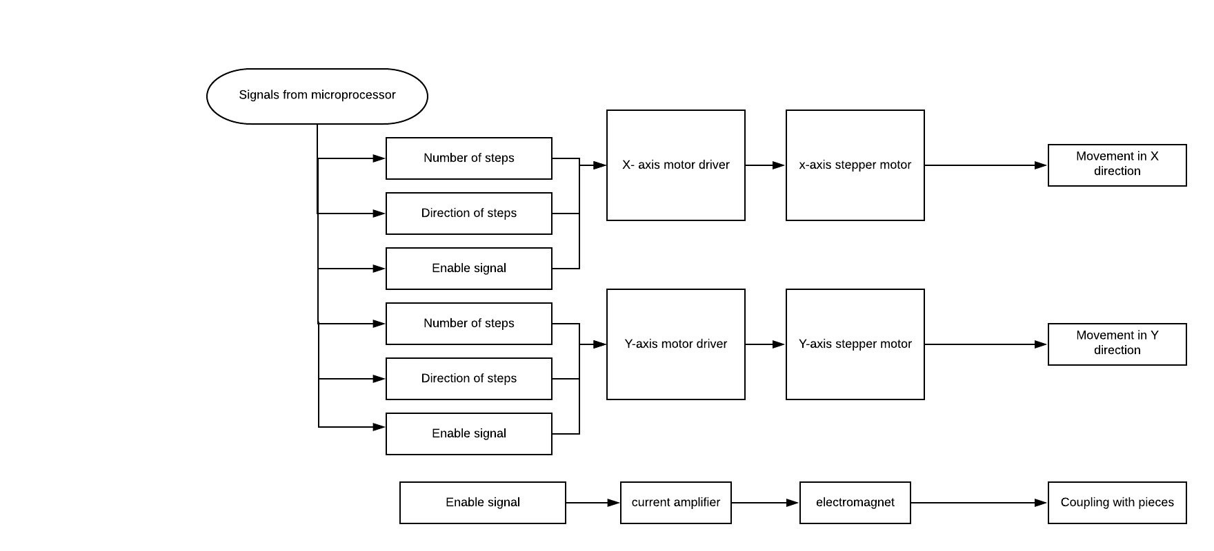

Fig 11. Working system.

**4.3 Typical game conversion**

Player1 : MOVE a2 a4 (for pawn)

Player2/AI : MOVE g8 f6 (for knight)

Player1 : MOVE c1 g5 (for bishop)

Player2/AI : MOVE a1 g1 (for rook)

**4.3.1 Observation table**

|  |  |  |  |
| --- | --- | --- | --- |
| Sr. No | Command | Move performed | time |
| 1 | A2 to A4 (Valid command) | As at A2 there a pawn then it will move towards the A4 position | Approximately 5-7 seconds |
| 2 | G8 to F6  (Valid command) | As at G8 knight is present and for knight moving at F6 is a valid command therefore it’ll move to that position. | Approximately 10-15 seconds |
| 3 | C1 to G5  (Valid command) | As at C1 bishop is present and for bishop moving at G5 is a valid command therefore it’ll move to that position. | Approximately 10-15 seconds |
| 4 | A1 to G1  (Valid command) | As at A1 rook is present and for rook moving at G5 is a valid command as well as non valid command cause first the system has to check id there is any pawn present or not otherwise it’ll move to that position. | Approximately 10-15 seconds |
| 5 | B8 to A7  (not a valid command) | System has to check if the piece present at that position can perform such move if not then it’ll display at the lcd screen that the command is not valid. | Approximately 5 seconds |

Table 2. observations.

**CHAPTER 5**

**Result**

A lot of time and effort was used to create the design of the chess board in the semester. This semester was the team’s chance to implement the design that was so thought carefully about. But due to some complications the team could not bring the project to its completion.

Following Gantt chart will show the timeline that has to be followed 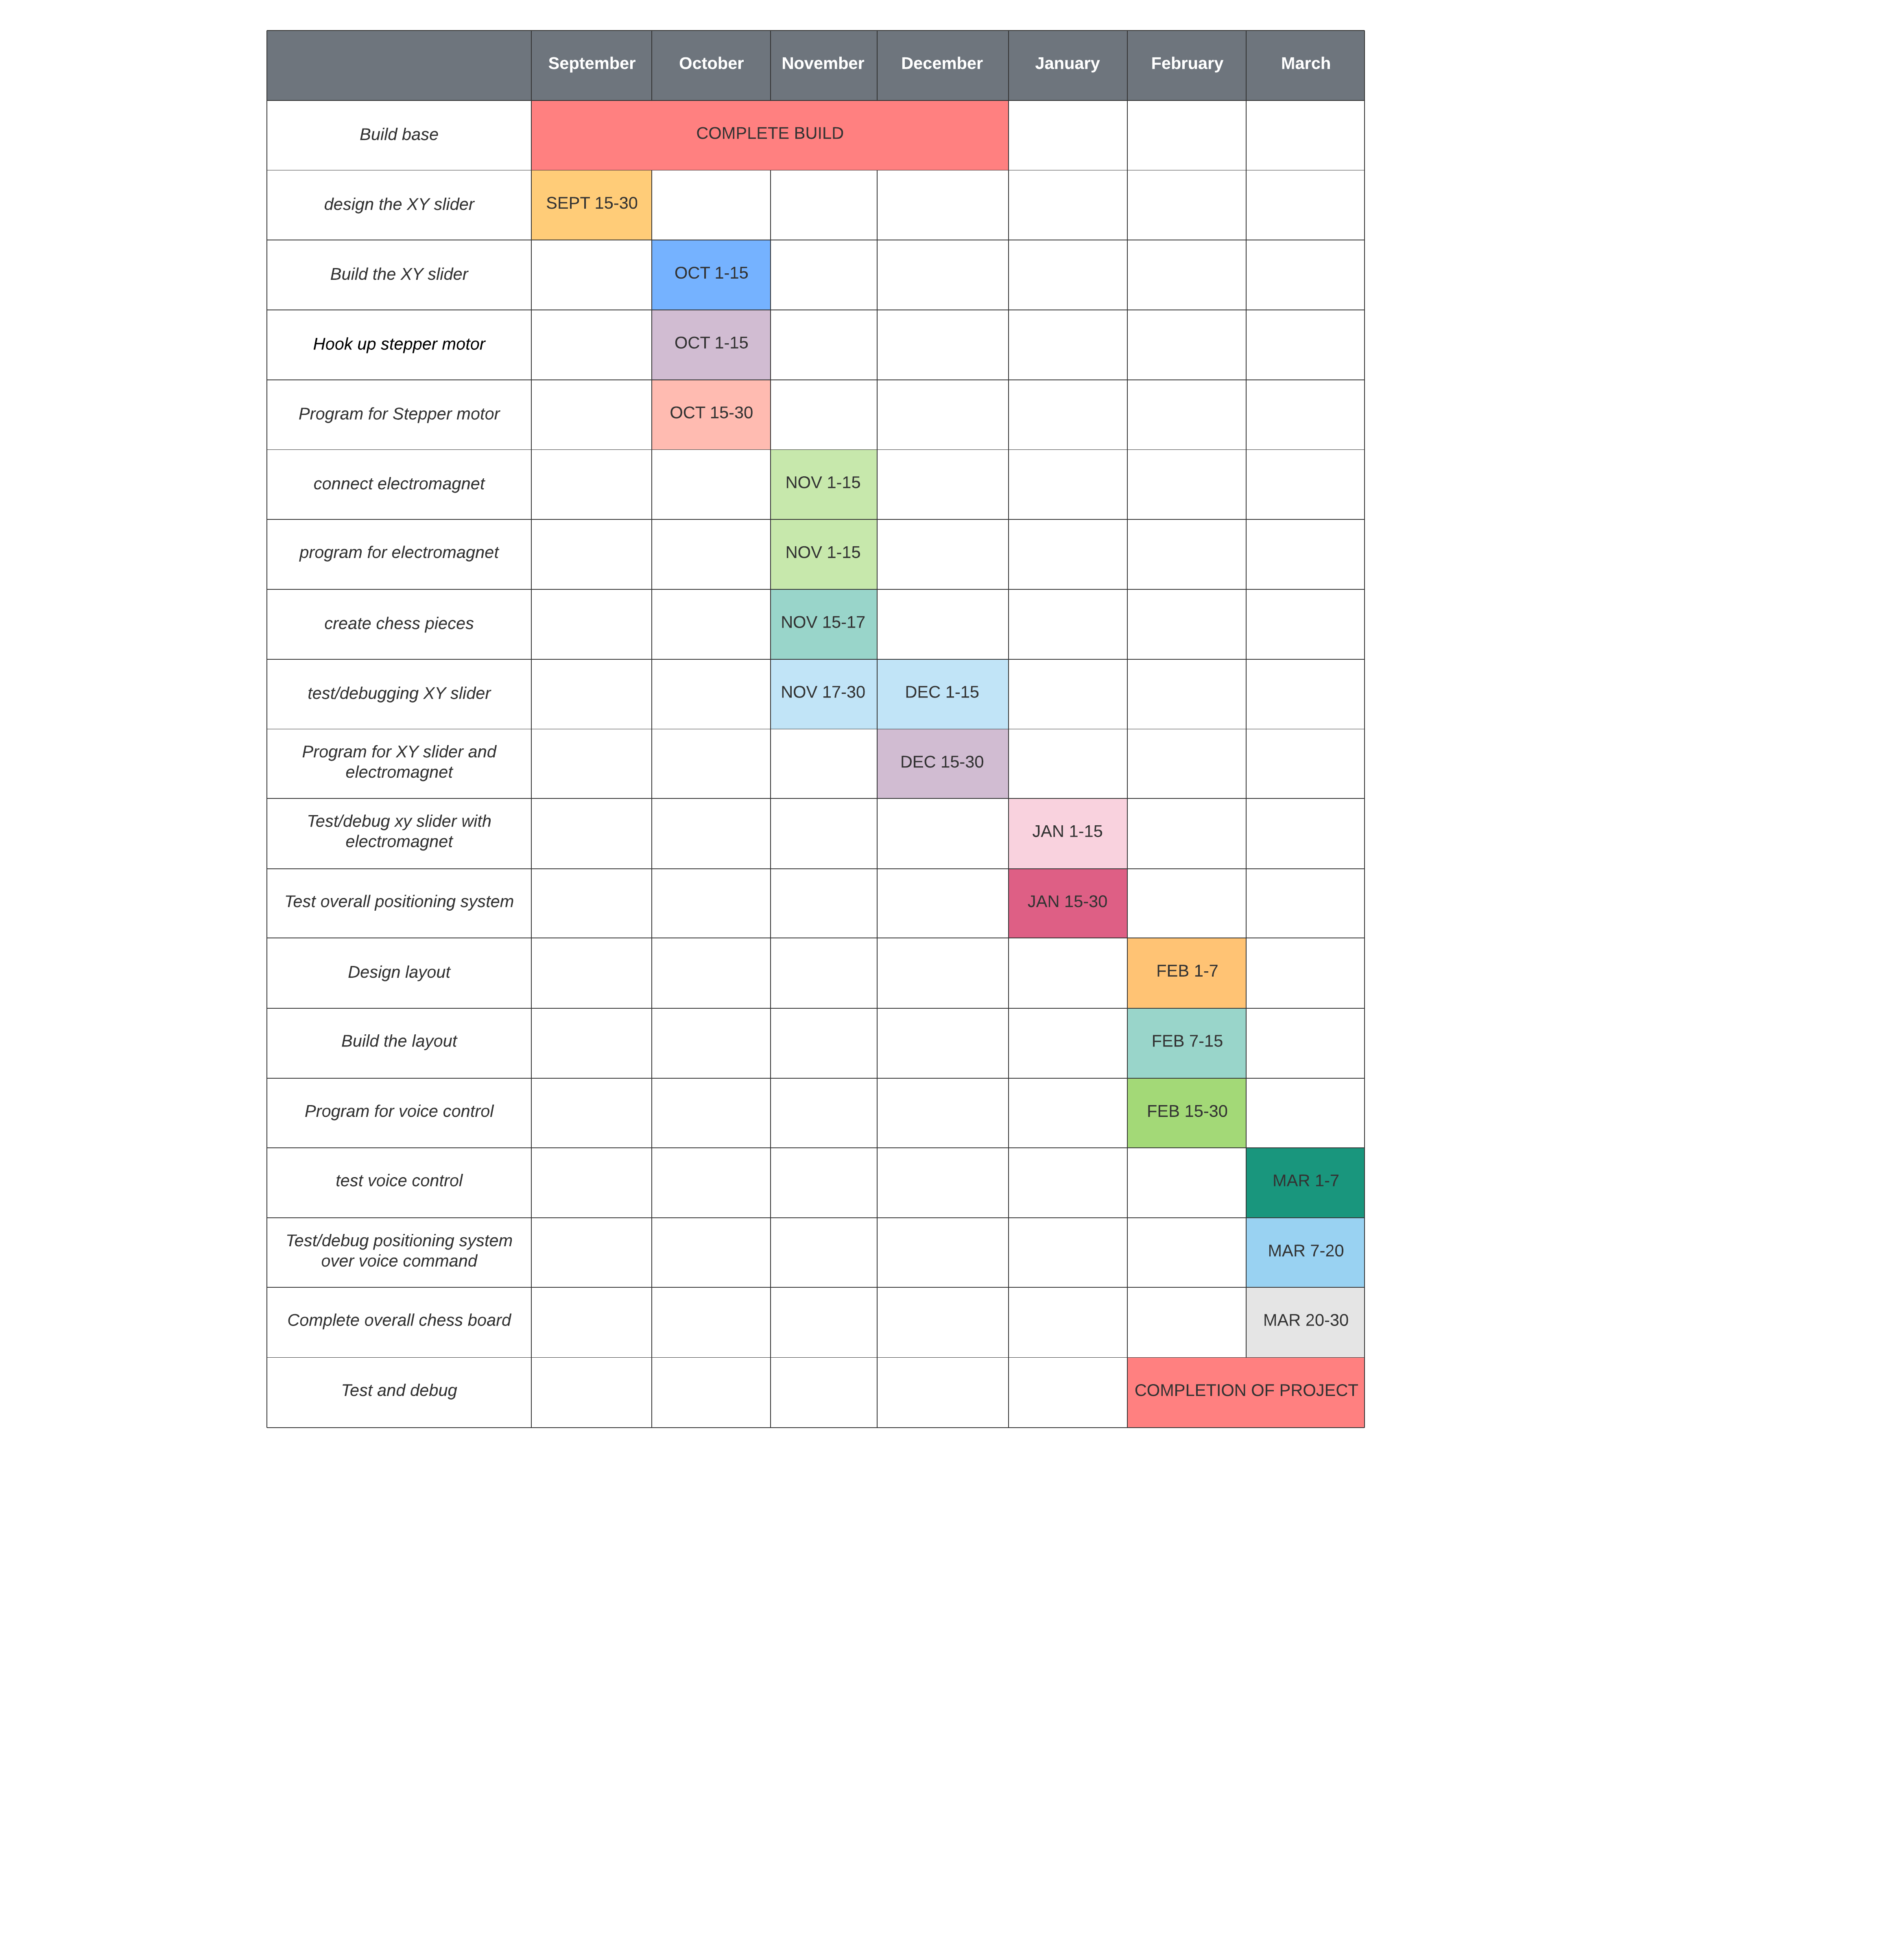

Table 3. Progression of the project.

The team could manage to complete the project around 75-80%. As shown in Gantt chart the test/debugging of positioning system and completion of overall board is not completed due to some complications.

**CHAPTER 6**

**Conclusions**

This project required a significant amount of time and effort, particularly in the previous semester when the design of the chessboard was carefully planned. This semester was focused on implementing that design, bringing the concept to life while addressing unforeseen challenges. Although the core design remained unchanged, three key modifications were necessary to improve the system’s functionality and efficiency.

The **replacement of the electromagnet with a solenoid** ensured that all chess pieces, including the largest ones, could be moved reliably without the risk of losing magnetic strength over time. Similarly, the **modification of the X-Y axis slider** from wheels to electric wire guards improved stability and movement precision, making the system smoother and more efficient. Lastly, **switching from a microphone-based voice input to a Bluetooth module with a smartphone app** eliminated speech processing difficulties while also making the system more cost-effective and user-friendly.

These adjustments, while causing minor delays in the schedule, ultimately enhanced the reliability and usability of the **Voice-Activated Chess Set**. The final design successfully meets its goal of providing an accessible, hands-free chess-playing experience, making the game more inclusive for individuals with physical limitations. Future improvements could include refining voice recognition accuracy, integrating AI-based move suggestions, or expanding the system for multiplayer online gameplay.

In conclusion, despite some challenges along the way, the project was successfully implemented, and the necessary modifications led to a **more effective and practical** final product.

**CHAPTER 7**

**Future Scope**

The designed system has wide future scope. Interfacing the system with online web servers like Stockfish will allow the user to play with different players virtually. Other games like Ludo, Arimaa, Chaturaji, Chaturanga, Djambi, etc can be programmed and played virtually. With further modifications, the system can be made more lightweight and travel portable. Launch of such products in market would have a raging demand.

**References**

1. Tai L. Chow, *Introduction to electromagnetic theory*, student Edition; jones & barlett.
2. The university of Akrons :" Honors research Project"

By Dr. Gary B. and Pamela S. Willims Honors College

1. Narasimha Karumanchi, *Data structures and algorithmic thinking with python.*
2. Underhill, Charles R. (1906). [*The Electromagnet*](https://books.google.com/?id=n9tYAAAAYAAJ&pg=PA113&lpg=PA113). D. Van Nostrand. p. 113. [Archived](https://web.archive.org/web/20160501182508/https://books.google.com/books?id=n9tYAAAAYAAJ&pg=PA113&lpg=PA113&hl=en&f=false) from the original on 2016-05-01.
3. “Voice chess, a chess board with voice commands” : by diyguypt

<https://www.instructables.com/id/Voice-chess-a-Chess-Board-With-Voice>

[6] H. Amason, J. Burbridge, B. Nottingham, T. Tran, “Magic Chess,” University of Central Florida. (Spring 2014) :

<http://eecs.ucf.edu/seniordesign/fa2012sp2013/g03/documents/SDCP2.pdf>